**Executive Summary**

Simple Budget is an intuitive web-based budgeting software, designed with the capability to handle multiple banks, transfers, transactions, and incomes. The access database has been populated with sample data, and a windows form app is included for reference. Relevant files, databases, and artifacts are available at <https://github.com/Rearsky/Simple-Budget>.

**General Layout**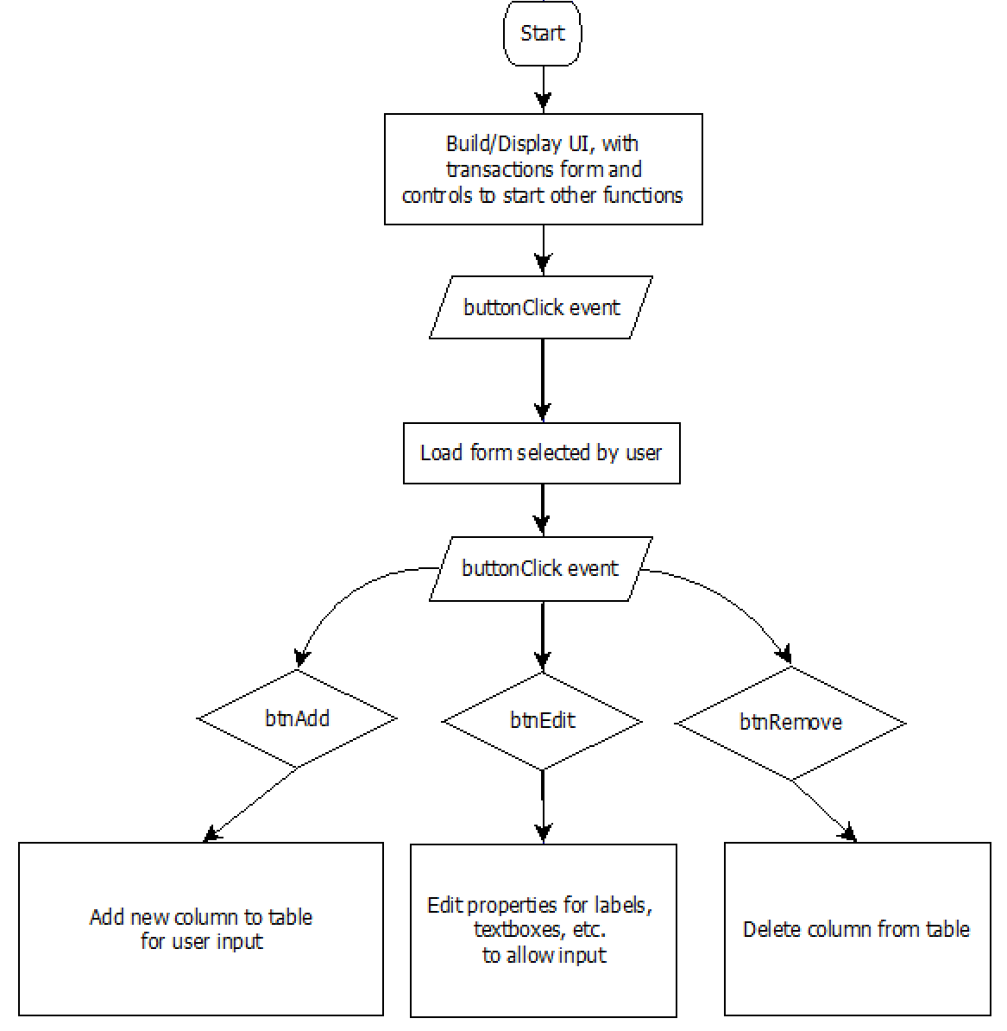

**Windows Form**

**(for reference)**

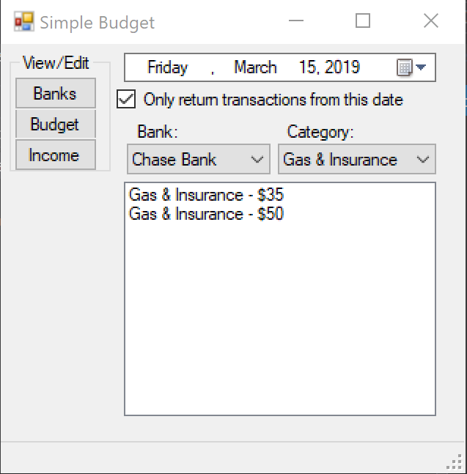

* **Multiple Bank Functionality**
* **Query using Date/Time and Category**
* **Ability to manipulate Banks, Budget, and Income in the database**

**Format**

* **Global use of Lower Camel Case**
* **Main form contains transaction management and controls to access secondary functions**
* **Foreign key for the category field in the transaction table, referencing the primary key ID in the budget table**

**Example Database Tables**

**Banks:**

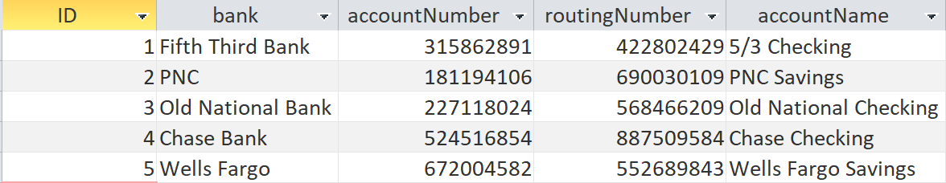

**The banks table consists of the user’s essential bank information. The banks function allows the user to append and remove data from the banks table.**

**Income:**

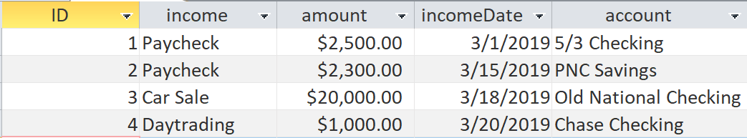

**The income table consists of the user’s tracked income. The income function allows the user to append and remove data from the income table.**

**Budget:**

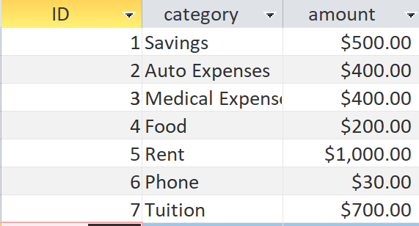

**The budget table consists of the user’s planned spending for each category. The budget function allows the user to append and remove data from the budget table.**

**Transactions:**

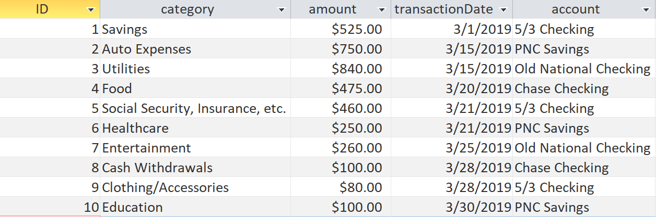

**The transactions table consists of the user’s inputted transactions. The transactions function allows the user to append and remove data from the transactions table.**

**Transactions, Bank, Budget, and Income Function Structure**

**Transactions**

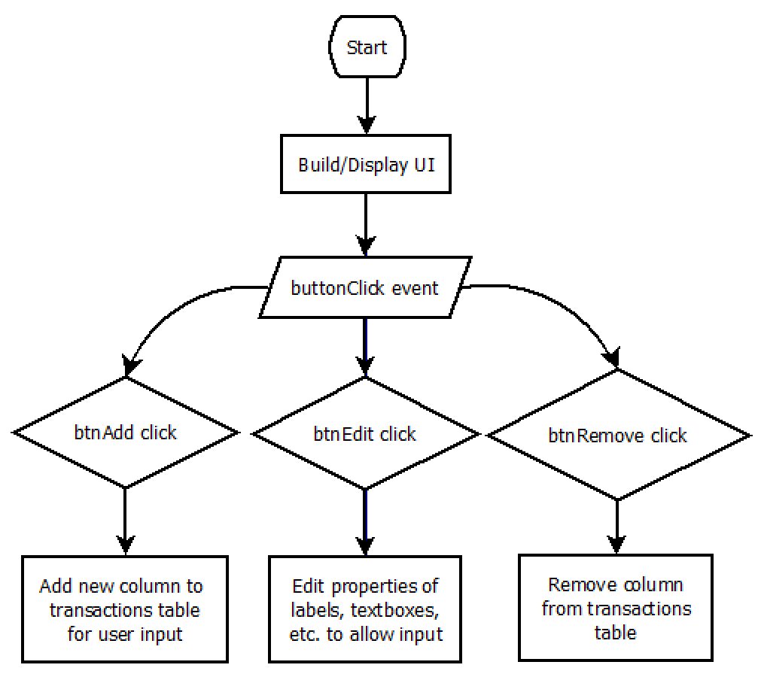

**Bank**

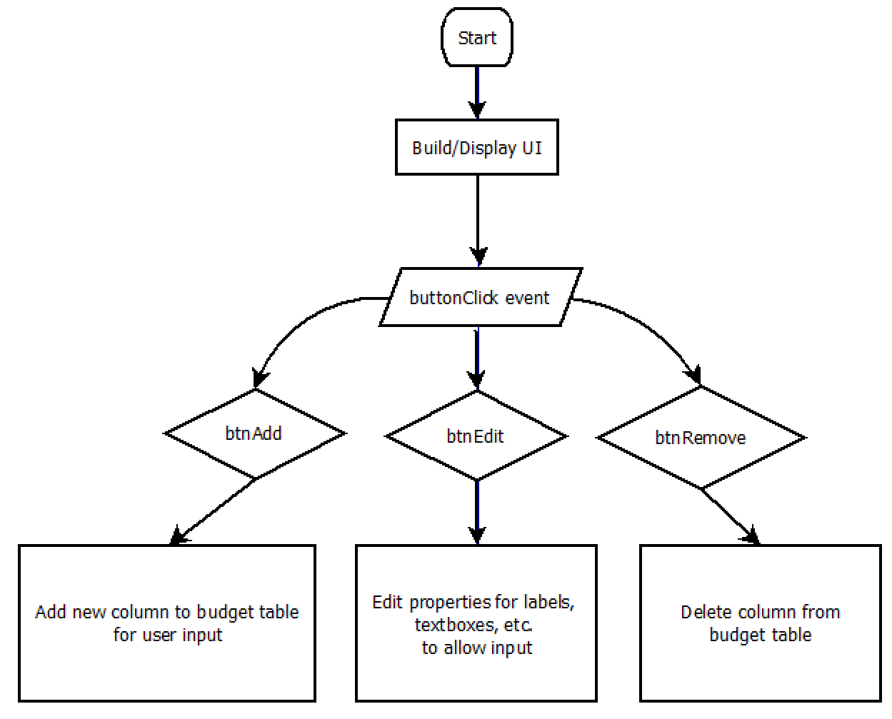

**Budget**



**Income**

